News from the House Agriculture Committee
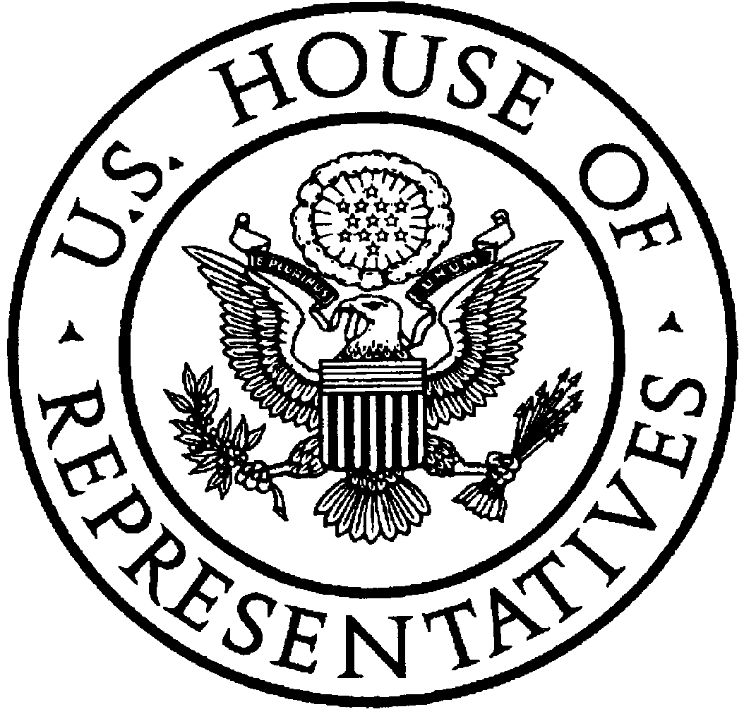
U.S. House of Representatives
Committee on Agriculture
Collin C. Peterson, Minnesota

Chairman

http://agriculture.house.gov

Opening Statement
Chairman Collin C. Peterson
House Agriculture Committee
Business Meeting to consider H.R. ___, The Commodity Markets Transparency and Accountability Act of 2008.
July 24, 2008

Good afternoon, and welcome to today’s business meeting.
We are here to consider draft language to amend the Commodity Exchange Act to bring greater transparency to commodity and futures markets.

I would like to thank my friend and Ranking Member, Mr. Goodlatte, as well as General Farm Commodities and Risk Management Subcommittee Chairman Bob Etheridge and Ranking Member Jerry Moran, for their participation in the process of crafting this legislation.

I also want to commend them for the work they have done this Congress staying on top of CFTC oversight and reauthorization while we were knee-deep in the Farm Bill process.

In addition, many other members of this Committee have worked very hard on important issues related to energy markets and have tirelessly advocated for farmers, ranchers and consumers who have been affected by volatile prices for energy and other commodities.

As the Committee with jurisdiction over futures and options markets, we take the amending of CEA very seriously and have approached this issue thoughtfully and with careful deliberation, for there are legislative remedies out there that could result in more volatile markets.

For three straight days earlier this month, this Committee held extensive hearings on amending the CEA, and the participation and interest from this Committee was strong, on both sides of the aisle. We heard from Members who have introduced legislation and we heard from a wide variety of stakeholder groups, including exchanges, traders, hedgers, commodity producers, buyers, and academic researchers. In short, we got as many points of view on these issues as we could.

Make no mistake; although difficult to quantify, the potential influence of speculative trading on futures markets is a real issue. While most people have focused on the price of crude oil, agricultural markets have also been in disorder, leading to a lack of convergence between cash and futures prices. This has caused real problems in farm country.

The language before the Committee today would bring much-needed transparency to commodities and futures markets, it would extend CFTC oversight to previously exempt over-the-counter markets, and it calls for new full-time CFTC staff to improve enforcement, to prevent manipulation, and to prosecute fraud.

This legislation would close the so-called “London loophole” by requiring speculative position limits for foreign boards of trade that trade U.S. commodities. It also requires those foreign boards of trade to share trading data and adopt position limits similar to U.S.-regulated exchanges.

It gives the CFTC the ability to get a complete picture of the swaps markets by subjecting those transactions to reporting and recordkeeping requirements. It requires large traders to report over-the-counter contracts and codifies CFTC’s recommendations in disaggregating data examining the extent of participation of index and other passive long-only funds in energy and agriculture markets.

It requires the CFTC to set position limits for energy and agricultural markets, in order to prevent excessive speculation while ensuring sufficient liquidity for bona-fide hedgers in the markets so that the price discovery function of the underlying market is not disrupted. It limits eligibility for hedge exemptions to bona-fide hedgers.

The bill calls for a minimum of 100 full-time CFTC employees to enforce manipulation and fraud in the commodities markets. CFTC staffing is currently at a record low despite record high trading volume. The CFTC has repeatedly asked for an increase in staffing, citing their low employment levels as a threat to their ability to effectively monitor the futures markets.

In addition, the bill would require the CFTC to study the effectiveness of establishing position limits in over-the-counter markets.

While this draft probably does not satisfy every member of this Congress with an interest in this issue, it does take meaningful steps to restore the commodity markets as a mechanism for price discovery and risk mitigation that work to benefit producers, processors, and consumers. I urge the Committee to approve it and I now yield to my friend and Ranking Member, Mr. Goodlatte, for an opening statement.

###

