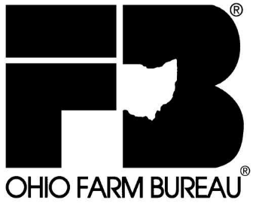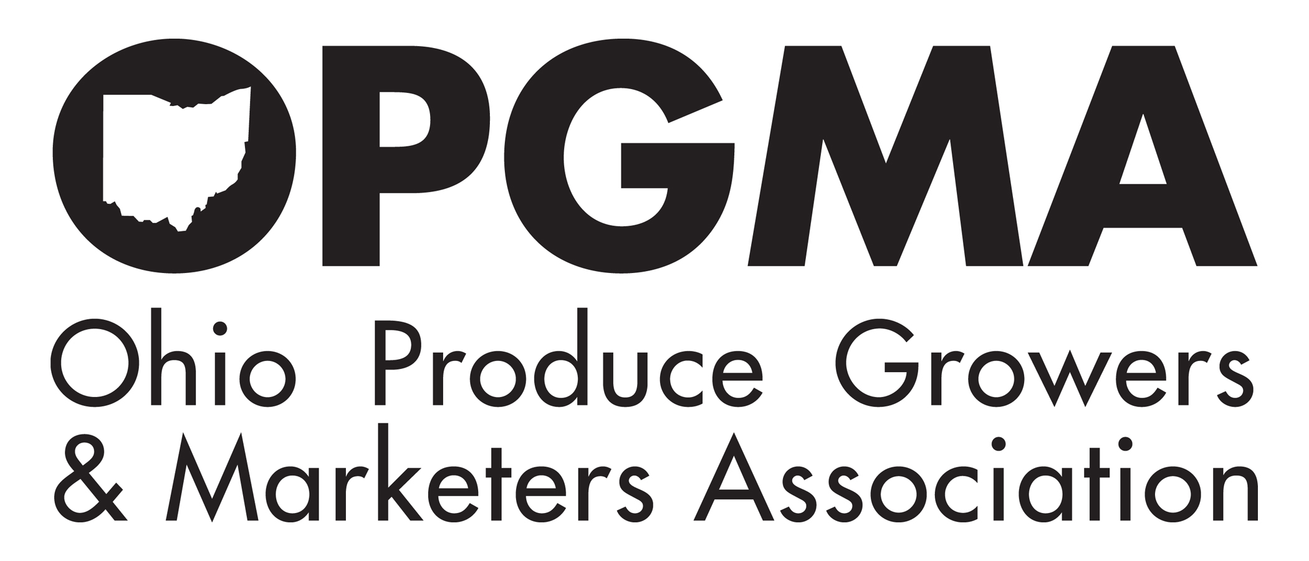

Statement of Steve Hirsch, Ohio Fruit and Produce Grower,
Member of Ohio Produce Growers and Marketers Association
and Vice-President of the Ohio Farm Bureau Federation

Before the
Committee on Agriculture
Subcommittee on Horticulture and Organic Agriculture
United States House of Representatives

Good morning Mr. Chairman and members of the Subcommittee, thank you for inviting me here today to testify on the very important issue of food safety. I am Steve Hirsch, together with my family we operate Hirsch Fruit Farm in Chillicothe, Ohio where we raise both fruit and vegetables including asparagus, tomatoes, peppers, cucumbers, apples, peaches, berries and more. I am testifying today as a member of Ohio Produce Growers and Marketers Association (OPGMA) and as the Vice-President of the Ohio Farm Bureau Federation.

The Ohio Farm Bureau Federation (OFBF) is the largest general farm organization in the state of Ohio with more than 200,000 members representing all of Ohio’s 88 counties. Our members produce virtually every kind of agricultural commodity and as a result, OFBF is very interested in the nation’s food safety policy.

The Ohio Produce Growers & Marketers Association (OPGMA) is an organization of produce growers and marketers whose goal is to produce exceptional quality crops, for consumers and processors, utilizing environmentally friendly practices.

My family operates two farm markets, one located at our farm and a second several miles away. We sell 85% of our produce and fruit directly to the public and the rest whole sale. We are members of the Chillicothe Farmers Market and buy and sell products at our local produce auction. We embrace a suite of food safety practices on our farm, in our markets, at the produce auction, and at the farmers market. There are many common themes among these practices but they can vary. They vary because these environments differ and require food safety practices tailored to provide the customer the safest and highest quality food possible per these different settings. Which is the theme of my testimony today.

In my view compliance is the key to the success of any new food safety system and any new system should be flexible in nature so growers can comply. Ohio produce growers vary in size ranging from larger operations that grow, pack, and ship their produce both in-state and across state lines, to very small farmers who sell all their produce directly to the local public. These farms are located throughout the state and are situated sometimes in the middle of suburbs to very rural areas. Some are located near the shores of Lake Erie, while mine is literally on a mountain top in Southern Ohio. Some irrigate from surface water, others use ground water, some are near livestock operation and others no-where near livestock.

My point, of course is that a single national, one-size-fits-all structure will not work and a national food safety system that allows for specific on-farm practices to be developed at the state level will achieve the best results. To this regard let me make several points;

First, State-by-State Flexibility Per On-Farm Practices. Flexibility per best management practices (BMPs) is key to the success of any new food safety system, as different growing regions on a national, even at a state level, vary significantly. For example, Ohio produce growers tend to be involved in growing, packing and shipping of the product, this isn’t the case in other areas of the country. Different regions of the country use production land very differently as well, such as continual use of specific land for produce production versus shifting use of land between pasture, other crops and production of vegetables. One of our Ohio leafy green growers has noted that his production systems are vastly different from another grower just 50 miles away. A state-based program could better recognize more localized management issues such as the locations of feedlots, wildlife challenges and more.

To even more specifically illustrate this point there are several issues within the draft National Leafy Greens Marketing Agreement (NLGMA) that are of concern to Ohio growers such as several water use issues, animal intrusion and boarder distances surrounding crops. These specifics were designed around California’s cultural practices and are not conducive to Ohio and many other state’s accepted practices. The draft also subdivided the country into zones that are far too large with far too much variance in cultural practices between the northern and southern states which are all included in single zones. The zone that includes Ohio, for example, stretches as far north as Wisconsin and a far south as Alabama. These vertical slices across the U.S. need to be redefined to a state-by-state division.

Second, Sound Science. We believe any new practices should be based upon proven and effective food safety practices and sound science. Most of our produce is not produced in an indoor or enclosed environment and should not be regulated in a manner that is unrealistic to achieve. Currently some of science assumptions behind the California Leafy Greens approach are now being called into question. These challenges question the contamination threat related to water quality and animal intrusion. I suggest the federal government take the time to fund and complete the science and research needed to determine the most appropriate and safe practices to assure a safe food supply before moving forward with any vast new system.

Third, State Coordination. Any new program should be coordinated with State departments of agriculture or other agencies responsible for food safety, inspection and enforcement. Such coordination will be crucial to the success of new programs and will prevent redundancy in programming. We need to bolster the funding, education and training for inspectors and when inspections are needed, such inspection should be conducted by and coordinate with state lead agency, such as the Ohio Department of Agriculture in Ohio, versus an FDA inspector on the farm. The Ohio Farm Bureau office receives calls daily from small growers, organic growers, backyard hobbyists and gardeners all very concerned, right or wrong, with some of the legislative ideas being proposed on Capitol Hill per new food safety systems. Flexibility would go a long way to addressing many of these concerns.

Fourth, Economic Impact. We emphasize the need for any new program to be organized in a manner that allows the strength of existing state-based systems to aid in the success of improved food safety, especially given the severe budget challenges that States currently face. Furthermore. the development of any new system should consider the economic impact on various size operations across the county. In Ohio, we have one of the largest, if not the largest, concentration of Amish farmers in the country. These produce growers do not use electricity and use horses in the fields to cultivate. They must pick, pack and sell their produce all in one day. They also keep horses outside the production areas during harvest time. These are a few of the many specific examples that highlight the need for flexibility. We also want to make it clear that Ohio, and likely other states, are at a distinct disadvantage per possible compliance costs because we must spread costs over a shorter growing season, as opposed to some states like California, that can spread costs over the entire year, given their longer growing season. Any new system should be economically viable within existing industry structures that vary across the country.

In closing, as we move forward in improving upon the safest, most abundant food system in the world, let’s remember to be practical, cost-effective, use sound science, allow flexibility for states to work with growers in developing best practices and recognize, embrace and built-upon the diverse food production system we have in this county. Thank you. I’ll be happy to take any questions.

