

Testimony of

Fred Bauer

For the
Independent Community Bankers of America

Before the

House Agriculture Committee
Subcommittee on Conservation, Credit,
Energy and Research

Hearing on

“Credit in Rural America”

June 11, 2009
Washington, D.C.

Credit in Rural America

Introduction

Mr. Chairman and members of the subcommittee, thank you very much for the opportunity to testify today on a topic of great interest to this committee, our nation’s farmers and ranchers, and the thousands of community banks in rural America.

My name is Fred Bauer and I am the President and CEO of Farmers Bank in Ault, Colorado. I am testifying on behalf of the Independent Community Bankers of America and I serve on ICBA’s Agriculture-Rural America committee. I am also Chairman of the Independent Bankers of Colorado. I am pleased to present ICBA’s views on credit conditions in rural America.

Farmers Bank of Ault has been in existence for 103 years. The present ownership has owned the bank since 2001. We branched to Ft. Collins two years ago. Ours has always been an "ag" bank, but we have diversified over the last ten years given the opportunities in our trade area, which is the north front range of Colorado. Agricultural lending still accounts for 40 percent or more of our business.

As an agricultural lender, we are very diversified serving dairies, feedlots (cattle and sheep), ranchers, beet, onion, carrot, wheat, alfalfa, dry bean, and corn farmers. Our community has approximately 1500 people, but there are approximately 300,000 people within 20 miles of our bank. Additionally, we service small business customers, consumers and real estate interests (land holding, development and construction).

This morning I will briefly provide the community bank perspective on credit conditions in rural America and offer recommendations for the members of this subcommittee to consider in order to ensure the viability of our farms and ranches and rural economies.

The Financial Crisis

As the financial crisis spread and deepened last fall many people wondered what the impact of the worst economic recession since the Great Depression would be on the agricultural sector. At the outset, let me emphasize that community banks played no part in causing the financial crisis and have been quite upset at the bailout of the Wall Street investment firms and our nation’s largest banks that have been considered “too big to fail.”
Dozens of community banks have been allowed to fail during the past two years while the largest banks have been prevented from failing due to governmental intervention.

Community banks did not cause the current financial crisis, which was fueled by exotic lending products, subprime loans, and complex and highly leveraged investments that went terribly awry. The sharp decline in the U.S. housing markets and the distressed credit markets triggered a ripple effect throughout the entire nation that continues to strain households and impact our economy.

Community Banks Role in the Rural Economy

Community banks play an important role in the nation’s economy. There are approximately 8,000 community banks in the U.S. and the vast majority of these are located in communities of 50,000 or fewer residents. Thousands of community banks are in small rural communities.

Community banks have only 12 percent of all bank assets but make 20 percent of all small business loans. This is important since small businesses represent a whopping 99 percent of all employer firms and employ one-half of the private sector workforce. Small businesses are important in rural America since many farmers and/or their spouses have off-farm jobs. In addition, the more than 26 million small businesses in the U.S. have created 70 percent of the net new jobs over the past decade. Community banks are small businesses themselves and specialize in small business relationship lending.

Community banks under $1 billion in assets make over 60 percent of all agricultural loans extended by the commercial banking sector. Even more astounding, community banks under $500 million in assets extend over 50 percent of all agricultural credit from the banking sector. Commercial banks extend approximately 53 percent of non-real estate loans to the farm sector and 38 percent of the real estate credit.

Aite Study

The Aite Group LLC released a study, conducted with the assistance of the ICBA, in March on the impact of the financial crisis on community banks. The study drew several conclusions that are informative regarding the ability of community banks to continue serving their customers during the financial crisis.
Although the current financial crisis is impacting all financial institutions, most community banks are well positioned to overcome new challenges, take advantage of new opportunities, and reclaim some of the deposits lost to larger institutions over the last decade.

Despite most community banks’ lack of participation in subprime lending, the implications of larger bank activities have begun to trickle down. Of the 773 community banks surveyed, 73 percent stated they have seen an increase in their traditionally low loan delinquencies and charge-offs since the start of the crisis. The significant growth in quarterly net charge-offs for the industry is being driven primarily by the largest banks.

Fifty-five percent of bankers stated they have seen an increase in deposits as a result of new customer acquisition. Only 17 percent are challenged by customers withdrawing deposits from their institutions.

Community banks are still lending and 40 percent have seen an increase in loan origination volumes over the last year while 11 percent believe the financial crisis has “significantly curtailed” their lending ability. In several cases, decreases in community bank lending activity, when it has occurred, is not the result of a lack of funds or financial instability, but rather part of a reaction to mixed messages coming from the U.S. government. While these banks hear the government’s requests for them to lend money, they also feel the government is dissuading them from lending by putting them through overzealous regulatory exams. Moreover, an economic contraction, by definition, means fewer loans will be originated; leading to bank’s curtailed ability to lend.

While some community banks are faced with new lending challenges, they are still lending, especially when compared to larger banks. In fact, while the largest banks saw a 3.23 percent decrease in 2008 net loans and leases, institutions with less than $1 billion in assets experienced a 5.53 percent growth.

The financial crisis and new documentation requirements are also causing some banks to change processes and re-evaluate their credit evaluation practices. While most community banks have not strayed from traditional prudent lending and underwriting practices, 81 percent have tightened their credit standards since the start of the crisis. Of banks surveyed, 20 percent described this tightening as significant. Banks with more than $100 million in assets have been the most likely to tighten their credit standards, while only 15 percent of banks with less than $100 million in assets have done so. In most cases, tighter standards often means focusing greater attention on risk management and requiring more borrower information prior to making lending decisions.

The Agricultural Sector – Farm Income

Many rural lenders have been quite concerned that a global recession would lead to fewer exports of U.S. agricultural products, thereby reducing markets and income for American farmers, and causing a ripple effect up and down Main Street. The agricultural sector was fortunate that at the outset of this severe recession, in which unemployment figures continue to march toward double digit levels, U.S. net farm income had reached a record high of nearly $90 billion for 2008.

This followed the $87 billion level reached in 2007 and a ten-year average (1999-2008) of $65 billion. However, production expenses also increased dramatically during the past two years, and although expenses are projected to be approximately 9 percent lower this year, net cash income is also projected to fall to $71 billion. While still above the ten-year average, 2009 net farm income will be 18 percent less than last year’s record level, according to USDA’s Economic Research Service.

Perspective on Agricultural Credit

We agree with various economists who have noted there is an ample amount of credit available to the agricultural sector for credit worthy borrowers. However, we also point out that there are several problem areas of concern that warrant continued monitoring. For example, the dairy industry has been hard hit by lower prices and high feed costs which have also impacted the livestock sector. In addition, there are several states where farmers have been impacted by drought conditions that will threaten yields and farm income.

As was recently pointed out to another subcommittee in April, despite some increasing risks in agriculture, ample credit appears available at historically low interest rates. In addition, the FDIC’s recent data indicates that farm loans (non-real estate) and farm real estate loans increased collectively by $8 billion for the period ending March 31, 2009 compared to March 31, 2008.

ICBA’s Agriculture-Rural America Committee Input

ICBA conducted a conference call last week with its Agriculture-Rural America committee to further assess credit conditions. This committee consists of twenty-five agricultural bankers from every region of the U.S. representing virtually every agricultural commodity grown in the country.

A number of these bankers stated they had no classified agricultural loans. This is in part due to several areas of the country having excellent crops during the past two years, allowing farmers to increase their cash reserves or pay down their lines of credit. Some bankers have seen a significant increase in agricultural loans and have seen little deterioration in their agricultural portfolios but are concerned that higher input costs will reduce farm income. Some community banks have picked up agricultural loans as larger banks have cut back their lines of credit. Land values have remained steady for highly productive farm land although sales have slowed considerably.

Land values for less productive farmland have fallen 5 to 10 percent in some areas. Some banks have tightened underwriting standards, including taking a stronger collateral position, slightly shortening loan maturities, or requiring greater documentation from borrowers. The dairy, cattle feeding and cow-calf sectors are areas experiencing stress.

Several bankers stated they are concerned with the potential for their regulators to second-guess their desire to make additional loans and some bankers are under pressure from their regulators to decrease their loan-to-deposit ratios. In addition, several bankers stated their regulators do not want them to utilize Federal Home Loan Bank (FHLB) advances as a means of funding their loans. The regulators are suggesting that FHLB advances are not as “stable” as core deposits. Bankers disagree, noting that it is quite easy for depositors to withdraw funds in search of higher yields in the stock market, which has risen rapidly in recent months, or in shopping for higher rate CDs at other institutions.

The real issue, bankers believe, is that regulators do not want to be in a secondary security position behind the FHLB if there are widespread bank failures. FHLB advances have become an important source of funding for community banks that must be allowed to continue.

A number of bankers also complain about a very harsh examination environment from field examiners and believe there is a disconnect between the public statements from agencies in Washington D.C. and the treatment of local banks during examinations.

At least one banker relayed that when he called to inquire about receiving TARP funds he was questioned on why he needed the money. When he explained he wanted to supplement his capital position and also make more loans, the regulator told him the agency didn’t want banks making more loans in this environment. This type of attitude has led many community banks to conclude there is a reluctance to extending TARP money to community banks and that the program was primarily designed to assist large, troubled banks. Community banks in danger of failing would not be eligible for TARP funds.

In addition, many banks have concluded that TARP funds are an expensive source of capital both in terms of the dividend cost as well as the administrative costs. There is also the threat that requirements will be changed after banks receive funding and new conditions will be imposed.

Generally, the bankers’ assessment is that ample credit is available for credit worthy borrowers; they would like to make more loans; and they’re concerned about heavy-handedness from their regulators going forward. Community banks remain very well capitalized and are in a good position to assist with new borrowing needs as the economy strengthens.

There are some sectors of agriculture that are struggling, but the agricultural portfolios of many rural banks are currently a very strong contributor to the bank’s overall income and stability.

New Frontier Bank Failure

Recently, a $2 billion bank with heavy involvement in agriculture, and located in northern Colorado, failed. The bank apparently took a lot of risks in its effort to grow quickly, achieving all of its growth in the past ten years. As Chairman of the Independent Bankers of Colorado, I facilitated a meeting a few weeks ago between the local bank presidents, the State Division of Banking, representatives of the Federal Reserve, and the local representatives of the FDIC in charge at New Frontier, providing a venue to exchange information about what everyone could expect over the next few months. The meeting was also an opportunity to voice concerns over what would or could happen to an already struggling local economy given New Frontier's demise. One concern was the potential negative impact upon existing farmers and ranchers if there was a large and sudden glut of real estate for sale due to a number of foreclosed properties. Also of concern was dealing with the many customers seeking new credit relationships.

We agreed to meet again after the dust had settled. Many of the banks are reviewing New Frontier’s loan portfolio to determine if there are bankable loans that they could add to their own portfolio. Bankers of course want to be sure that the borrowers are capable of repaying their loans if they extend them credit. Regulators also expect banks to lend to borrowers that can repay. Our bank looked at a number of these loans and will acquire at least four in our trade area.

One limiting issue is that regulators recently decided to require community banks to increase their capital levels once again. Previously, regulators increased our capital level from 8 percent to 10 percent. Now the regulator requires banks to have a 12 percent capital

level for all banks that have commercial real estate loan volumes three times their level of capital (e.g. $30 million in commercial loans and $10 million of capital). Obviously, the regulators believe that commercial real estate loans are more vulnerable in the current economic climate. Many banks in northern Colorado exceed this threshold due to the region’s fast growth in recent years. However, since capital is leveraged approximately ten times for new lending, a $2 million required increase in capital reduces the amount of lending the bank is able to provide by $20 million. Many bankers in our area believe this new requirement is unnecessarily restrictive.

Federal Reserve Agricultural Surveys

Several of the Federal Reserve District banks (Kansas City, Dallas, Chicago, Minnesota, and Richmond) conduct quarterly agricultural surveys of bankers in their regions. A summary of these surveys follows.

The Federal Reserve Bank of Kansas City notes that the average return on assets (ROA) and equity (ROE) at agricultural banks steadily declined in 2008. ROE at ag banks last September declined to 7.6 percent and ROA declined to 0.8 percent. Yet, these returns were much stronger than returns at other commercial banks. Contributing to the decline in ag bank profits were lower interest rates which have dropped significantly below 2006 levels. At smaller banks, delinquency rates on agricultural loans actually declined. Delinquency rates and net charge-offs on agricultural loans remain well below other types of loans and help explain the relative strength of agricultural banks. The delinquency rate on all types of loans and leases in the third quarter of 2008 was almost triple the rate on agricultural loans. Ag banks report ample funds for operating loans.

Banks have tightened lending standards to preserve capital and manage risk arising from the economic downturn. Collateral requirements rose almost 20 percent above year-ago levels but this increase does not appear to have severely restricted loan activity as farm real estate accounted for approximately 17 percent of the collateral used for the nation’s farm operating loans. Bankers report deteriorating loan quality as livestock profits were elusive and margins declined for the crop sector. Carry-over debt appears to be rising as more ag banks report an increase in operating loan renewals and extensions during the fourth quarter. In response to rising risks, banks reduced the length of operating loans to approximately 12 months.

Rising job losses from the recession pose a risk to deposit growth because people could lose their income stream and tap savings for household needs. Ag banks are increasing their use of USDA guaranteed farm loans.
Continued deterioration in the ag economy could further erode the creditworthiness of ag borrowers. Farmland values edged down in the fourth quarter.

The Federal Reserve Bank of Minneapolis reports that farm income, capital expenditures and household spending decreased in the first quarter. Loan demand was flat and collateral requirements increased. Banks reported no shortage of funds and interest rates decreased from the fourth quarter of 2008. Survey respondents expect decreases in income and capital expenditures during the second quarter. Dairy producers are hard hit as the price of milk has fallen to below breakeven levels. Most respondents from Wisconsin report below average income for their borrowers. One quarter of Minnesota respondents reported above average income, but 49 percent reported below average income. Producers are responding to lower spending by reducing capital equipment spending. Approximately 25 percent of respondents reported lower levels of loan repayments and 19 percent reported higher levels. Twenty-five percent saw higher renewals or extensions and only 8 percent saw lower levels.

The Federal Reserve Bank of Dallas includes the states of Texas and portions of New Mexico and Louisiana, a region which has been impacted by a severe drought. Many ranchers are unable to reach a breakeven point, forcing livestock liquidations. The dairy industry is suffering from large losses. The outlook for crop production, due to the lack of moisture, remains bleak. Eighty-four percent of bankers report that loan demand remains unchanged or has decreased compared to last quarter.

The Federal Reserve Bank of Chicago reports sale of farms were below the levels of the prior year. Bankers anticipate declines in land values during the second quarter. For the second quarter of 2009, respondents expect higher loan demand for operating loans and USDA guaranteed loans. As of April 1, District interest rates had reached historically low levels with the level for operating loans at the lowest since the early 1970s. The average loan-to deposit ratio was 76 percent, or 4 percent below the desired level. As land values have stalled, cash rental rates for farmland increased 7 percent for 2009. Twenty-one percent of bankers reported that more funds for lending were available than a year ago and 9 percent reported that fewer funds were available.

Bankers expect the volume of non-real estate farm loans to grow during the second quarter compared to year ago levels and expect higher FSA guaranteed loan demand. They expect farm machinery, grain storage construction, feeder cattle and dairy loan volumes to decrease.

The Federal Reserve Bank of Richmond’s fourth quarter 2008 survey reported the demand for farm loans was little changed from its sharp drop off in the third quarter, which bankers attributed to variations in commodity prices and production costs. Lenders expressed concern about escalated feed costs which had reduced profits for livestock production. Requests for loan renewals or extensions increased at a quicker pace. Agricultural lenders reported that farm loan availability turned positive, and collateral requirements eased slightly from third quarter levels. Reports also indicated that interest rates for agricultural loans moved lower across all categories. Compared to third quarter levels, rates for intermediate-term loans decreased 34 basis points and rates for operating loans moved down 28 basis points. In other categories, interest rates for long-term real estate loans fell 19 basis points, and interest rates for feeder cattle loans dropped 10 basis points.

In the fourth quarter, 75 percent of lenders reported that they had actively sought new farm loans, up slightly from last quarter’s reading of 73 percent. Fourth quarter land prices were slightly below the previous quarter and considerably lower than year ago levels. Bankers expected farm loan volumes in the first quarter of 2009 to continue a downward trend led by further weakness in the demand for dairy and feeder cattle loans.

National Ag Risk Education Library Survey

In an effort to better understand what is happening in the agricultural economy, a survey was conducted in January 2009 by the Extension Risk Management Education Regional Centers and the Center for Farm Financial Management at the University of Minnesota, funded through the USDA CSREES Risk Management Education Program. Twenty-three hundred agricultural professionals responded to the survey, whose respondents represented various agricultural disciplines: Lenders – 21 percent; educators – 43 percent; crop insurance representatives – 7 percent; consultants – 6 percent – elevators, cooperatives, marketing brokers and non-profits 22.5 percent.

Currently, 63 percent of respondents stated that 10 percent or less of the producers they work with are experiencing financial stress, with 15 percent indicating that less than 2 percent of the producers they work with are currently experiencing financial stress.

In the next three years, however, more than 28 percent of respondents expect at least 30 percent of their agricultural clients will experience financial stress. Seventy-five percent of respondents expect 11 percent or more of producers will experience financial stress in the next three years.

Twenty-six percent of lenders think the probability is very high that producers will experience financial stress in the next three years. Fifty-four percent of lenders expect the probability of financial stress to be “high.”

It is particularly interesting to note the reasons stated for expected financial stress in agriculture over the next three years. The first five reasons given were: Price / input cost margins; price volatility; negative cash flows; inadequate business planning; and lack of financial planning skills. Tightening credit availability was sixth on the list of thirteen reasons and was cited as having “moderate” impact. The lowest rated factors expected to have an impact on farm financial stress were rising interest rates and declining land values.

Farm Credit System Considerations

The Farm Credit System (FCS) is a government sponsored enterprise (GSE) that is unique in that, unlike other GSEs, it competes with private sector lenders at the retail level. The financial crisis has proven that not only do GSEs have the implicit backing of the federal government; they also have the explicit backing of the federal government. Just like the nation’s largest banks, they would not be allowed to fail in times of financial difficulty.
The FCS, as a competitor of community banks, also has unique advantages – it can typically raise funds cheaply in the government debt markets and FCS institutions have numerous tax advantages enabling them to offer lower rates than commercial bank competitors.

This has led to FCS entities cherry picking prime farm loans from community banks as FCS institutions seek the very best customers from bank portfolios. Allowing this practice, unintended by Congress, can discourage community bank involvement in the agricultural sector, reducing the amount of resources and institutions available to farmers.

The performance numbers of the FCS indicates this as well. Compared to commercial ag banks’ ROE of 7.6 percent and ROA of 0.8 percent for September 2008, FCS associations’ ROE for the same time period was 10.85 percent and associations’ ROA was 1.70 percent.

Community banks serving agriculture should receive the same tax benefits as FCS associations. In this century, it no longer makes sense to provide billion-dollar and multi-billion dollar FCS institutions tax advantages over much smaller commercial lenders to compete for the same customers. The benefit of equalizing the playing field will accrue to the end-user, the farmers and ranchers.

ICBA Recommendations to Congress

While it is difficult to predict accurately what will happen in American agriculture two or three years down the road, we believe that Congress can have a positive influence by
making wise decisions now on a number of key policy choices. Our recommendations are as follows:

1. Keep the farm safety net intact without budget cuts. The 2008 farm bill was difficult to enact but represented an important investment in rural America’s future. As such, the funding commitments should be kept in place because many lenders and farmers have made long term planning decisions based on the farm bill’s safety net. ICBA has joined over three dozen other interested organizations in recent letter(s) to Congress explaining the rationale for requesting no further cuts to the farm bill.

2. Provide additional funding for USDA direct and guaranteed farm loans. Appropriations bills in both the House and Senate contain significant new money to meet recent projections for increased demand for direct and guaranteed farm loans. It is our understanding that the dollar numbers in the House bill are closer to meeting expected demand for direct operating loans. The house ag appropriations bill would provide $400 million of direct operating loans, $300 million in direct ownership loans and $50 million in guaranteed operating loans. However, it appears that approximately $150 million in guaranteed operating loans will be needed to meet demand so more money should be added for guaranteed operating loans. These programs assist borrowers who cannot obtain credit elsewhere and are an important backstop for farmers who need temporary assistance until they are able to graduate to commercial credit.

3. Enhance USDA’s Business and Industry (B & I) loan program. Congress added significant new money for USDA’s rural development efforts as part of the recently enacted economic stimulus package (P.L. 111-5). The new funding would allow an additional $3 billion of business and industry loans in addition to $1 billion of loans provided as part of USDA’s regular budget. However, the funds to provide $3 billion in new B & I loans will expire October 1, 2010. It will be important for USDA to aggressively market the program to lenders and provide adequate information in order to utilize these new funds.

Even more importantly, we believe the B & I program needs to be enhanced (at least for the new funding) by: A) implementing no more than a 1 percent origination fee; B) increasing guarantees on loans under $5 million from the current 80 percent level to 90 percent – perhaps even 95 percent on smaller loans; and C) not eliminating the low doc application as USDA appears to be on the verge of doing for smaller loans.
These changes would help ensure the program is attractive enough for lenders and their customers and will ensure that Main Street rural America has the resources necessary to ride out any storms on the horizon that could result from stress in the agricultural sector.

4. Ensure that the FCA does not proceed with its Rural Community Investments Proposal. This proposal poses significant new risks to the FCS and its borrowers and should not be adopted. The proposal appears to be illegal and was never considered or authorized by Congress. It allows FCS to extend credit, mislabeled “investments,” for a vast array of purposes never intended by Congress. These purposes include extending credit for non-farm business financing, apartment complexes, construction projects and virtually any other purpose. This wide non-farm reach of FCS institutions will move FCS lenders further away from serving farmers and ranchers – the specific reason it was created and granted GSE tax and funding privileges.

5. Ensure that regulators not unduly restrict lending by community banks. Regulators can have a major impact on the ability of lenders to extend credit particularly if they engage in unduly harsh examinations at the local level. Many community banks believe this is occurring. Members of Congress should interact with regulatory agencies and stress the need to allow the banking sector to work with farm customers during difficult financial times that may lie ahead. Such regulatory flexibility allowed many farmers to survive the turbulent times of the 1980’s farm crisis but was the result of clear and strong messages sent by Congress.

6. Avoid unintended consequences resulting from imposing new requirements on the banking sector. In recent months there have been various proposals aimed at bank recipients of TARP funds that would impose unnecessary costs and regulatory burdens on banks. Such proposals have included requiring commercial banks to write down principal and interest on troubled loans as the first option to consider when restructuring loans. Bankers already work with their customers and utilize a wide variety of options to keep customers in business. Seeking to dictate from Washington formulaic regulatory regimens will only add to the costs and complexity of working with borrowers and is unnecessary.

Conclusion

Thank you, Mr. Chairman, for the opportunity to testify today. Clearly, community banks did not cause the problems that resulted in the financial crisis but have done their part to work with borrowers and have even increased their lending during a period of economic contraction. In addition, thousands of community banks are providing loans to farmers and ranchers at historically low interest rates. ICBA urges the subcommittee to adopt the recommendations provided in our testimony to enable the community banking sector to do even more to serve American agriculture and our rural communities. We look forward to working with you and the members of this subcommittee and full committee.

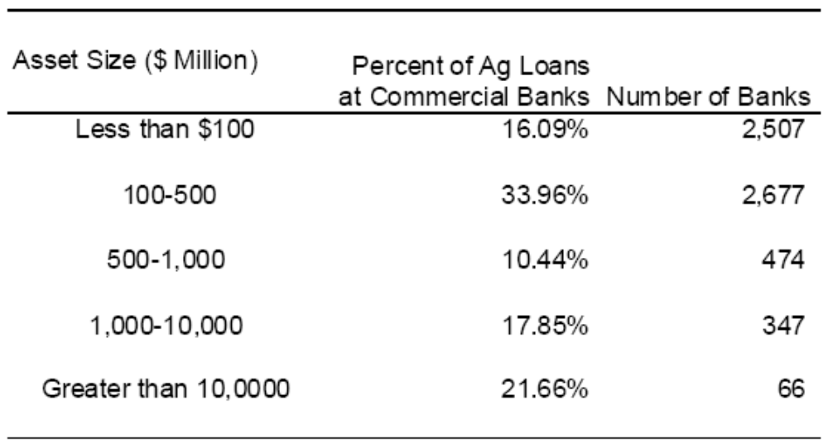

Source: Illinois Farm Economics Update, Financial Markets in Agriculture, Ellinger and Sherrick, October 15, 2008, p 3

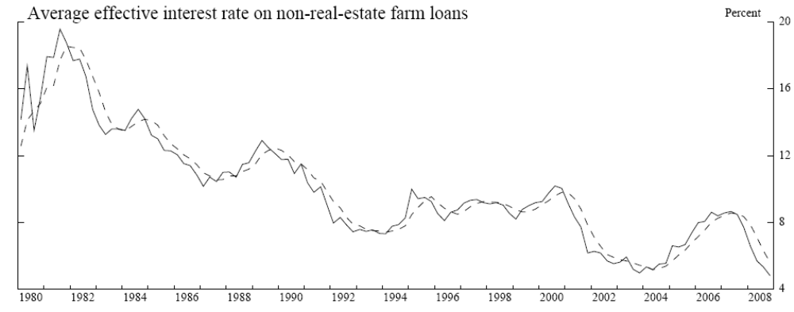

Source: Federal Reserve’s Agricultural Finance Databook, Dec. 2008

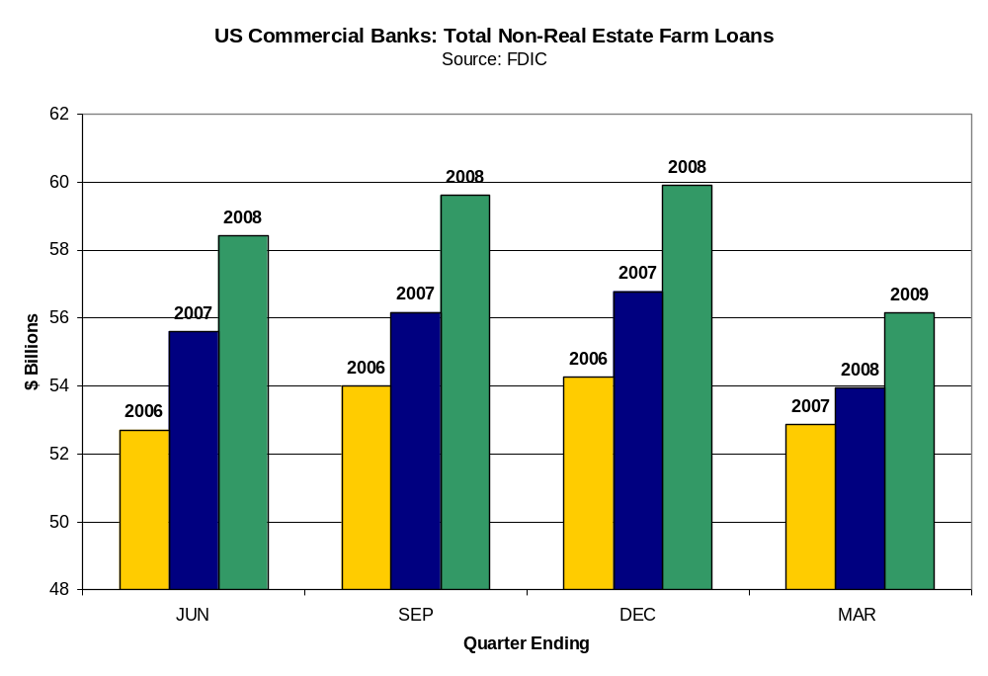
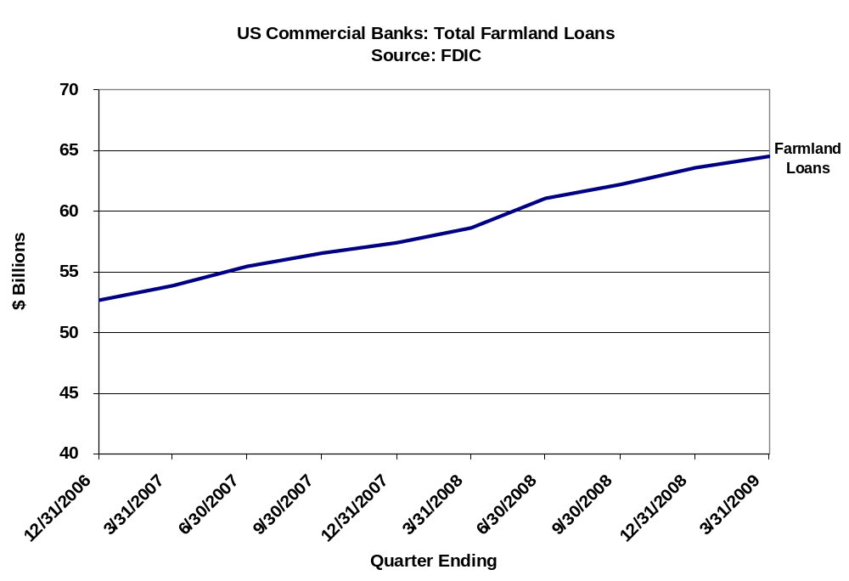
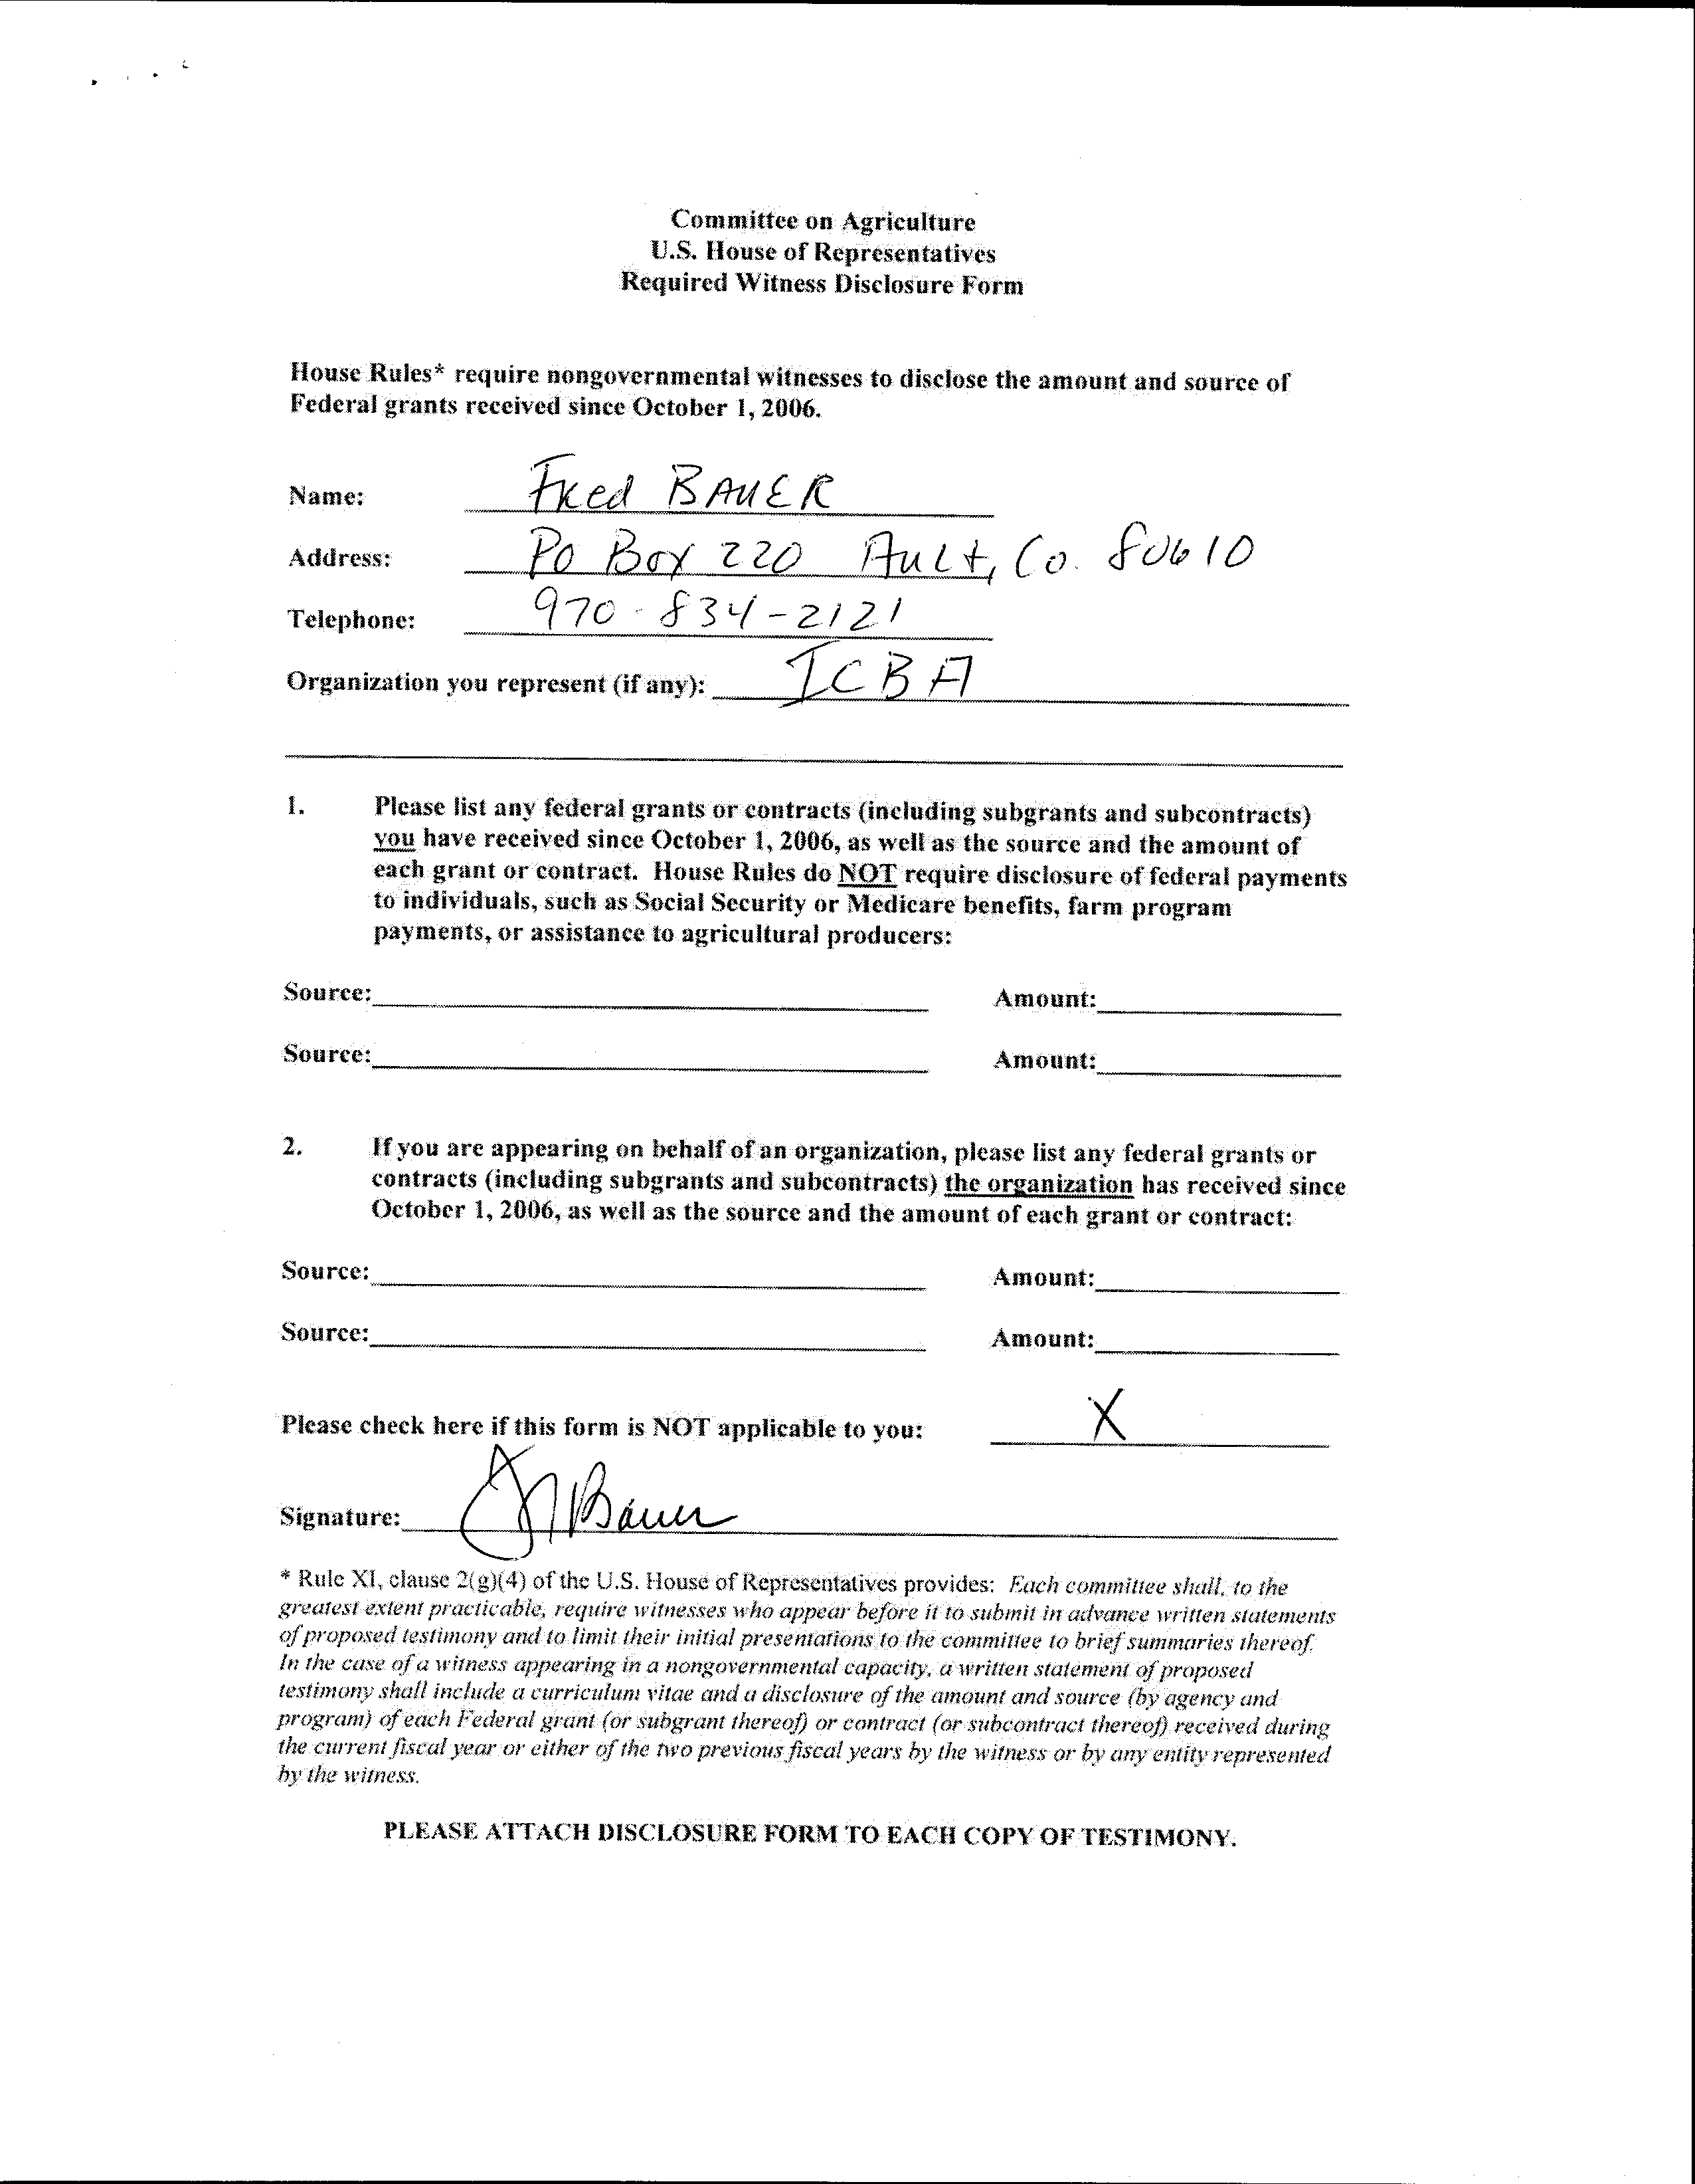
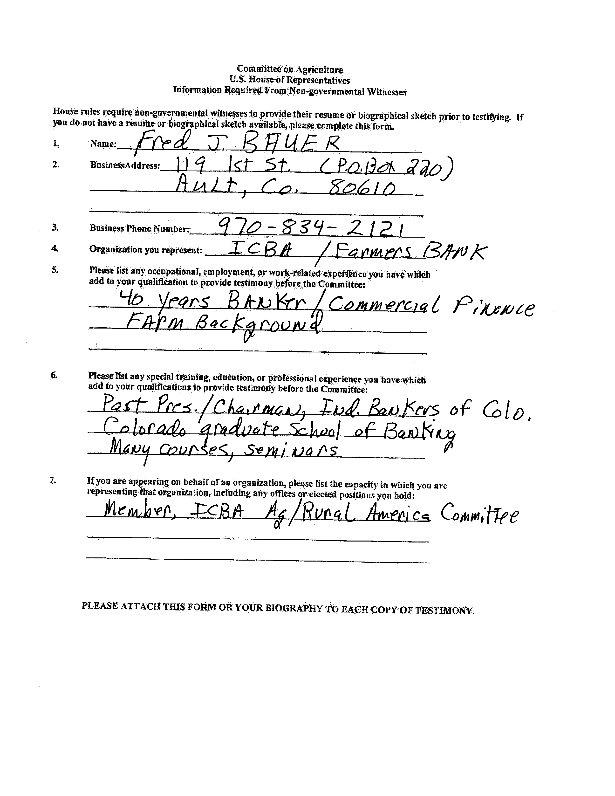

ICBA represents 5,000 community banks throughout the country. Community banks are typically independently owned and operated and are characterized by personal attention to customer service and are proud to support their local communities and the nation’s economic growth by supplying capital to farmers and ranchers, small businesses, and consumers.
Impact of the Financial Crisis on U.S. Community Banks, New Opportunities in Difficult Times, March 2009, Christine Barry and Judy Fishman, Aite Group LLC, Boston, MA. 773 community banks were surveyed in February, 2009, for this study.
Jason Henderson, Federal Reserve Bank of Kansas City before the Subcommittee on General Farm Commodities and Risk Management, April 1, 2009, page 2.
The cost of TARP funds includes a 5 percent dividend payment for the first five years increasing to 9 percent after five years. On an after tax basis, ICBA estimates the cost would be 7.5 percent the first five years and 13.5 percent after the first five years.
The Kansas City region, the Tenth Federal Reserve District, includes Colorado, Kansas, Nebraska, Oklahoma, Wyoming, the northern half of New Mexico and the western third of Missouri.
The Minneapolis Fed, serves the six states of the Ninth Federal Reserve District: Minnesota, Montana, North and South Dakota, 26 counties in northwestern Wisconsin and the Upper Peninsula of Michigan.
The Federal Reserve Bank of Dallas covers the Eleventh Federal Reserve District, which includes Texas, northern Louisiana and southern New Mexico.
The Chicago Fed serves the Seventh Federal Reserve District, a region that includes all of Iowa and most of Illinois, Indiana, Michigan and Wisconsin.
The Federal Reserve Bank of Richmond, (Fifth district) comprises Maryland, the District of Columbia, Virginia, North Carolina, South Carolina, and most of West Virginia.
This survey can be accessed at: http://www.agrisk.umn.edu/Library/Display.aspx?RecID=3971
Letter to Chairman DeLauro and Ranking Member Kingston, June 4, 2009 from 41 organizations

